**PRACTICAL – 5**

**AIM:**

**Subtract the contents of memory location 4001H from the memory location 2000H and place the result in memory location 4002H.**

**CODE:**

ORG 100H

MOV [4000H],0505H

MOV [2000H],0202H

MOV AX,[4000H]

MOV BX,[2000H]

SUB AX,BX

MOV [4002H],AX

RET

**OUTPUT:**

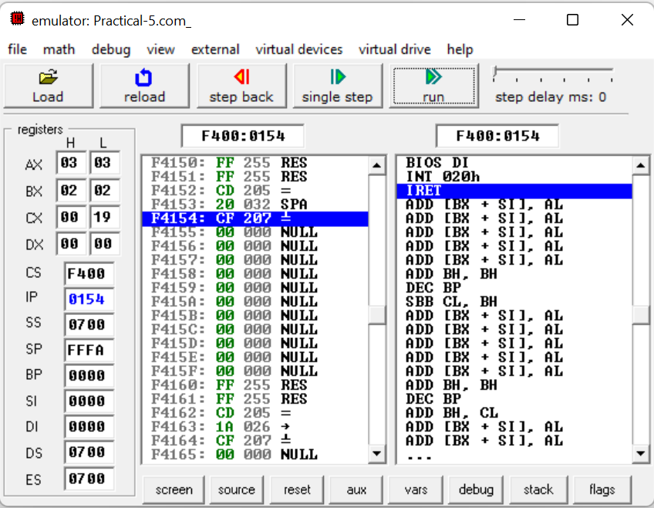

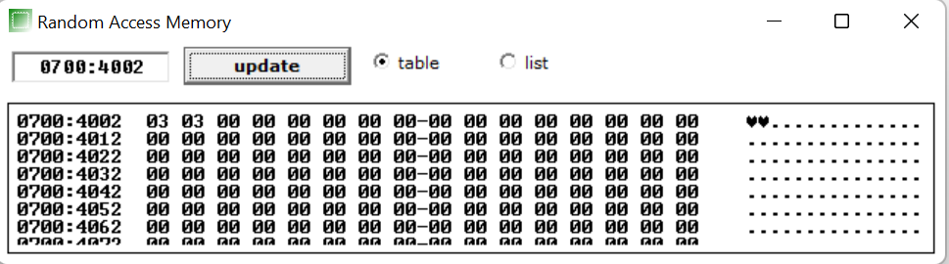

**CONCLUSION:** In this practical we learnt to subtract the contents of memory location and stored result in another memory location.